**V.R.Siddhartha Engineering College**

**Department of Information technology**

**A.Y:2022-23**

**20IT5301-Computer Networks Projects**

1. Simple Chat Program in JAVA – This is the Chat program with Client and Server. It includes two parts, the Server and the Chat. Both of them are net Beans 5.5 project. The executable file exits in dist. folder in both parts. Run the server part first then run the number of clients you want
2. Implement Sending and Receiving Data between Mobile and Data Logger: The goal of this project is to develop Mobile application using Bluetooth API to communicate with Data Logger and to receive the data and display on the screen. Special option should be created for the user to send the received data to web server. Main issue of using Bluetooth is to replace cables and low cost.
3. In the Bit Torrent P2P file distribution protocol the seed breaks the file into blocks, and the peers redistribute the blocks to each other. Without any protection, an attacker can easily wreak havoc in a torrent by masquerading as a benevolent peer and sending bogus blocks to a small subset of peers in the torrent. These unsuspecting peers then redistribute the bogus blocks to other peers, which in turn redistribute the bogus blocks to even more peers. Thus, it is critical for Bit Torrent to have a mechanism that allows a peer to verify the integrity of a block, so that it doesn’t redistribute bogus blocks. Assume that when a peer joins a torrent, it initially gets a .torrent file from a fully trusted source. Implement a simple scheme that allows peers to verify the integrity of blocks.
4. The goal of this programming assignment is to create a simple mail client that sends email to any recipient. Your client will need to establish a TCP connection with a mail server (e.g., a Google mail server), dialogue with the mail server using the SMTP protocol, send an email message to a recipient (e.g., your friend) via the mail server, and finally close the TCP connection with the mail server. For this assignment, the companion Web site provides the skeleton code for your client. Your job is to complete the code and test your client by sending email to different user accounts. You may also try sending through different servers (for example, through a Google mail server and through your university mail server
5. In this assignment, you will develop a Web proxy. When your proxy receives an HTTP request for an object from a browser, it generates a new HTTP request for the same object and sends it to the origin server. When the proxy receives the corresponding HTTP response with the object from the origin server, it creates a new HTTP response, including the object, and sends it to the client. This proxy will be multi-threaded, so that it will be able to handle multiple requests at the same time.

For this assignment, the companion Web site provides the skeleton code for the proxy server. Your job is to complete the code, and then test it by having different browsers request Web objects via your proxy

1. In this assignment, you will develop a simple Web server in Python that is capable of processing only one request. Specifically, your Web server will (i) create a connection socket when contacted by a client (browser); (ii) receive the HTTP request from this connection; (iii) parse the request to determine the specific file being requested; (iv) get the requested file from the server’s file system; (v) create an HTTP response message consisting of the requested file preceded by header lines; and (vi) send the response over the TCP connection to the requesting browser. If a browser requests a file that is not present in your server, your server should return a “404 Not Found” error message.
2. In the companion Web site, we provide the skeleton code for your server. Your job is to complete the code, run your server, and then test your server by sending requests from browsers running on different hosts. If you run your server on a host that already has a Web server running on it, then you should use a different port than port 80 for your Web server.
3. Suppose the network layer provides the following service. The network layer in the source host accepts a segment of maximum size 1,200 bytes and a destination host address from the transport layer. The network layer then guarantees to deliver the segment to the transport layer at the destination host. Suppose many network application processes can be running at the destination host.

a. Design the simplest possible transport-layer protocol that will get application data to the desired process at the destination host. Assume the operating system in the destination host has assigned a 4-byte port number to each running application process.

b. Modify this protocol so that it provides a “return address” to the destination process.

c. In your protocols, does the transport layer “have to do anything” in the core of the computer network

1. Tool similar to IDM , where you could download data in batches from different sources and assemble them in correct order
2. Something similar to online text editor - collabedit or Google docs where simultaneously 2 people can edit text .Try to integrate with it your chat-client
3. Implement Video Chat system (Look for WebRTC)
4. Implement Simple Chat client (P2P),Chat client with multiple participants (Sockets , Multi-threading)
5. Develop an Intelligent system for efficient traffic management in heterogeneous networks using mobile agents or fuzzy logic. It can have several parts like bandwidth calculator, Load balancer etc. For traffic management, Blocking probability equations are used.
6. Bit Torrent is a communication protocol for peer-to-peer file sharing, which enables users to distribute data and electronic files over the Internet in a decentralized manner. To send or receive files, a person uses a Bit Torrent client on their Internet-connected computer. When you download a web page like this one, your computer connects to the web server and downloads the data directly from that server. Each computer that downloads the data downloads it from the web page’s central server. This is how much of the traffic on the web works. Implement the Bit Torrent protocol.
7. Build your own version of Routing Information Protocol and implement Bellman-Ford Algorithms
8. Build your own HTTP server and client
9. Build a Reliable version of UDP for data transfer (Add TCP congestion Control and flow control)
10. OPNET standard application for FTP models the basic operations. OPNET simplify the multiple FTP applications and simulate the two main data transmission of FTP operation: get and put. FTP put operations are used to upload a file to FTP server and FTP get operation are used to download a file from the FTP server to the client nodes. In OPNET, the FTP application models the process of transferring files at a time. By default, FTP is running on top of the TCP. When using the default transport protocol, it opens a separate TCP connection for each file. Unlike in real networks, during the procedure of one file’s transferring operations, the FTP model uses the same TCP connection to send control messages and data modelling. Build a FTP server using OPNET
11. Add security features to SDN controller(eg pox)
12. Build attack programs for MAC flooding attack, DNS spoofing attack, DHCP spoofing attack
13. A cyclic redundancy check (CRC) is an error-detecting code commonly used in digital networks and storage devices to detect accidental changes to raw data. Blocks of data entering these systems get a short check value attached, based on the remainder of a polynomial division of their contents. On retrieval, the calculation is repeated and, in the event the check values do not match, corrective action can be taken against data corruption. CRCs are so called because the check (data verification) value is a redundancy (it expands the message without adding information) and the algorithm is based on cyclic codes. CRCs are popular because they are simple to implement in binary hardware, easy to analyze mathematically, and particularly good at detecting common errors caused by noise in transmission channels. Because the check value has a fixed length, the function that generates it is occasionally used as a hash function. Implement
14. Address Resolution Protocol (ARP) is a communication protocol used to find the MAC (Media Access Control) address of a device from its IP address. This protocol is used when a device wants to communicate with another device on a Local Area Network or Ethernet. Reverse ARP (RARP) - It is a networking protocol used by the client system in a local area network (LAN) to request its IPv4 address from the ARP gateway router table. A table is created by the network administrator in the gateway-router that is used to find out the MAC address to the corresponding IP address. Build an app which implements ARP and RARP
15. A checksum is a simple error-detection scheme in which each transmitted message that results in a numerical value based on the value of the bytes in a message. The sender places the calculated value in the message (usually in the message header) and sends the value with the message. The receiver applies the same formula to each received message and checks to make sure the accompanying numerical value is the same. If not, the receiver can assume that the message has been corrupted in transmission. The simplest form of checksum, which adds up the bytes in the data to form a sum value, cannot detect a number of types of errors. In particular, such the checksum value is not changed. Implement an app which checks weather there are any errors in the received data or not
16. Design and implementation P2P communication over internet: Skype like P2P application, WhatsApp like non P2P application
17. Design a Simulation of an email service using SMTP/POP3/IMAP protocol(Batch-15)
18. Develop Social media networking within an autonomous system using HTTP, DNS and DHCP
19. Develop Application: Instagram live series, Facebook live for mobile. Simulation of multimedia streaming service with UDP
20. OPNET standard application for FTP models the basic operations . OPNET simplify the multiple FTP applications and simulate the two main data transmission of FTP operation: get and put. FTP put operations are used to upload a file to FTP server and FTP get operation are used to download a file from the FTP server to the client nodes. In OPNET, the FTP application models the process of transferring files at a time. By default, FTP is running on top of the TCP. When using the default transport protocol, it opens a separate TCP connection for each file. Unlike in real networks, during the procedure of one file’s transferring operations, the FTP model uses the same TCP connection to send control messages and data modeling .Develop Simulation of FTP service using TCP by OPNET
21. Design and simulate of Virtual LAN
22. Traffic flow analysis with networking various topologies (Hierarchical, linear topology) using mininet
23. Simulation of IoT environment using packet tracer, real time IoT applications(Batch-18)
24. Simulation Of SDN
25. Simulation of Router configuration using Cisco Packet tracer
26. Configuration, simulation ,testing and troubleshooting of dynamic Routing protocols - OSPF & EIG with ACL in a CISCO routers
27. **Design and configure the Access point and wireless controller implementation in a network using packet tracer for the following network topology.** The Cisco Wireless Controller (WLC) devices are used to centrally configure and manage enterprise wireless networks, regardless of the number of access points deployed and the location. Wireless controllers have become very popular as companies move from standalone Access Point (AP) wireless designs. Design and Implement Cloud network in packet tracer.

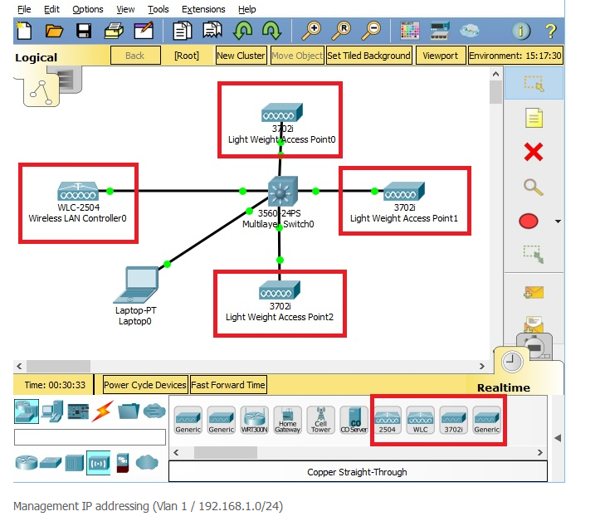

1. Configure RIP in Cisco Packet Tracer, Create the following topology and configure the devices as per the values mentioned in the following table. Consider the version of RIP is version 1&2

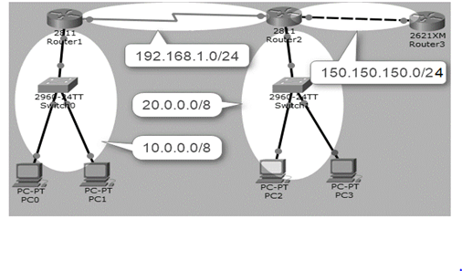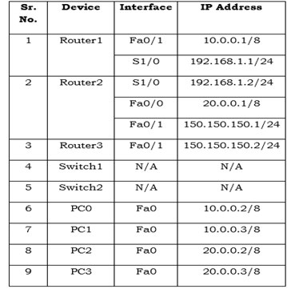

1. Implementation Static Routing on a network
2. Implementation of IS-IS Routing on a network
3. Implementation dynamic Routing on a network.
4. What is BGP (Border Gateway Protocol ) how its work with two  or more than two networks implement networks
5. Configure rip ipv6 in packet tracer
6. Configure cisco Wi-Fi Router using packet tracer on a network.
7. Configure VoIP Phone with CISCO Router & Switch in Packet Tracer
8. Design a Unicast ,multicast and broad cast network using cisco packet tracer
9. Make a LAN messager app. To chat with people connected to the same LAN network without using Internet and at the same time provides data encryption, privacy and security.
10. This project looks into the usage and collection of data by programs that operate behind the scenes. The collected data and its use by a network of sellers, brokers, and marketers represents a direct privacy threat as it can be used for marketing, profiling, crime, or government surveillance, and yet consumers have little knowledge about it and no legal means to access the data. ICSI researchers are conducting surveys and experiments to determine the current status of this data and observe its effects.